ESTIMATING
Pearson Edexcel - Tuesday 19 May 2020 - Paper 1 (Non-Calculator) Foundation Tier

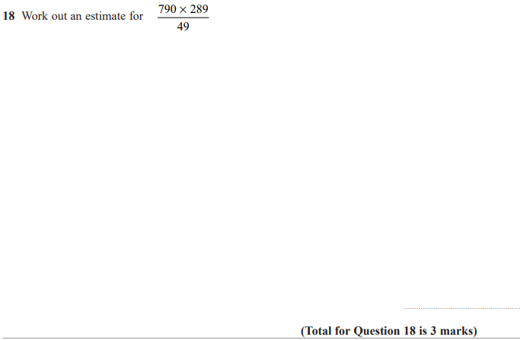

Pearson Edexcel - Tuesday 6 November 2018 - Paper 1 (Non-Calculator) Foundation Tier

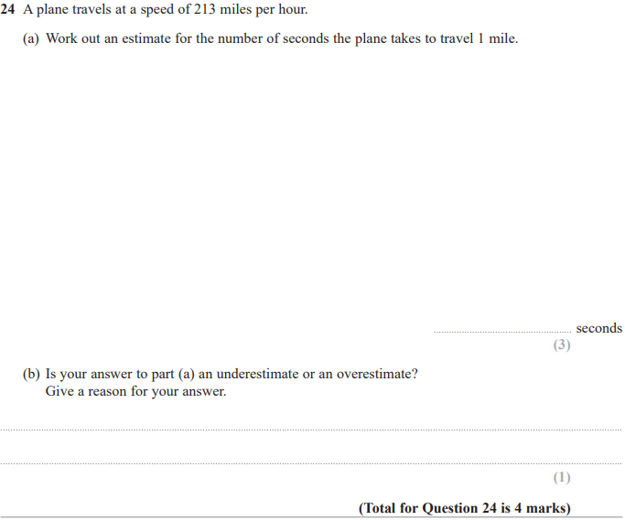

Pearson Edexcel - Thursday 2 November 2017 - Paper 1 (Non-Calculator) Foundation Tier

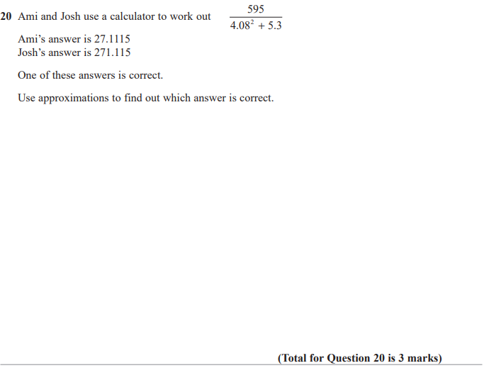

Pearson Edexcel – Specimen 1 - Paper 1 (Non-Calculator) Foundation Tier

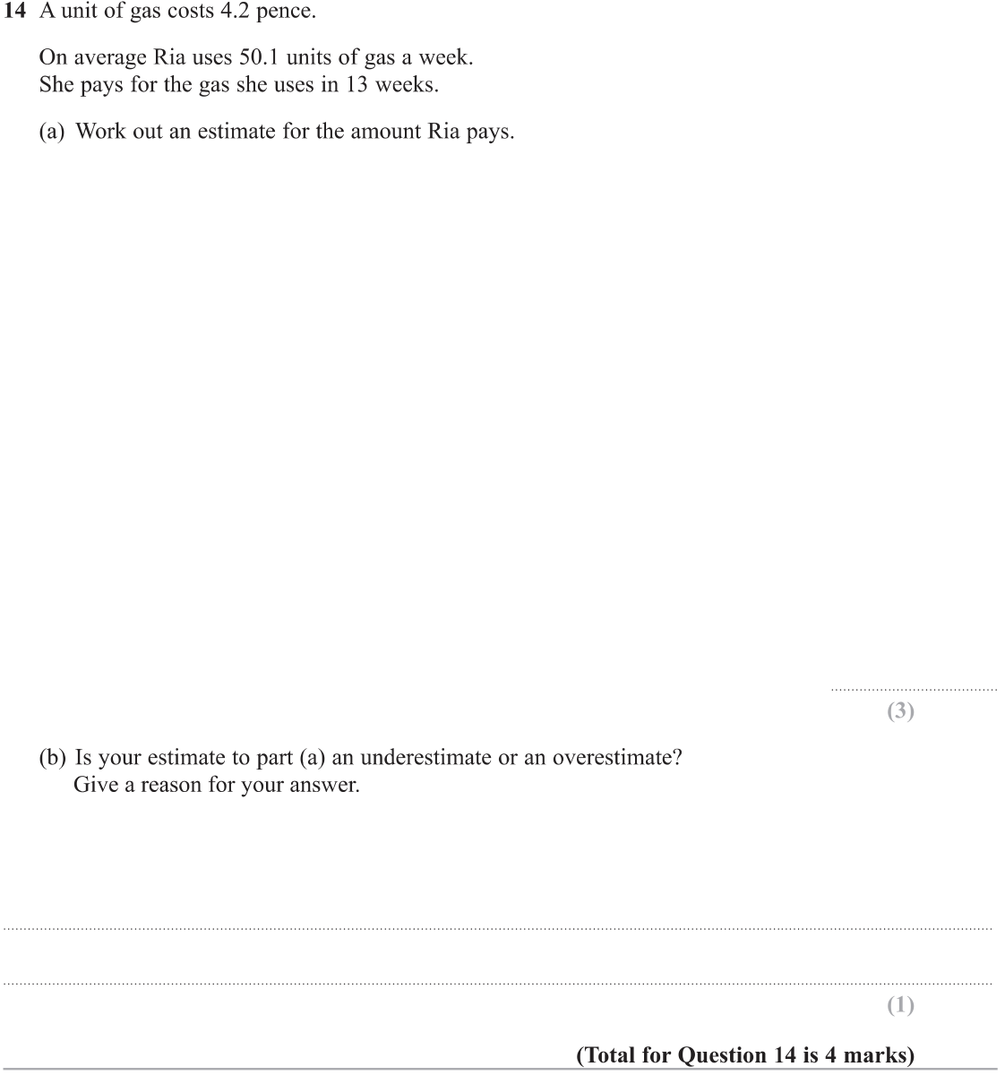

Pearson Edexcel – Specimen 1 - Paper 3 (Calculator) Foundation Tier

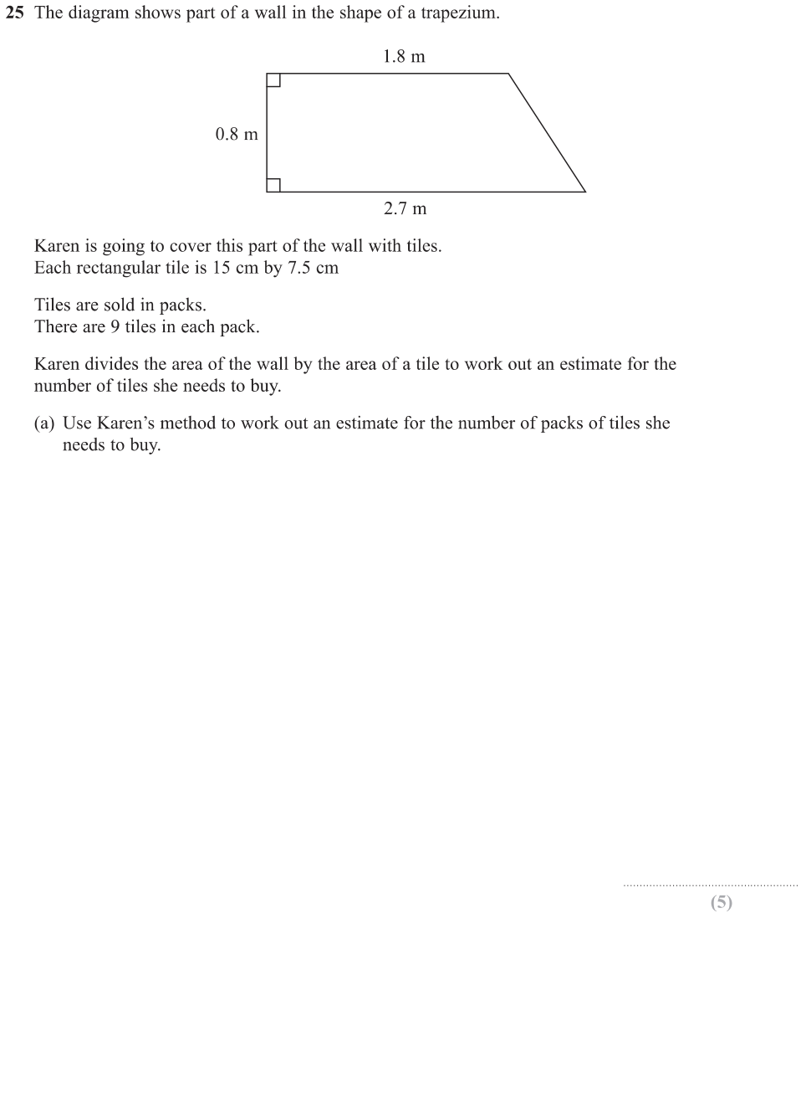
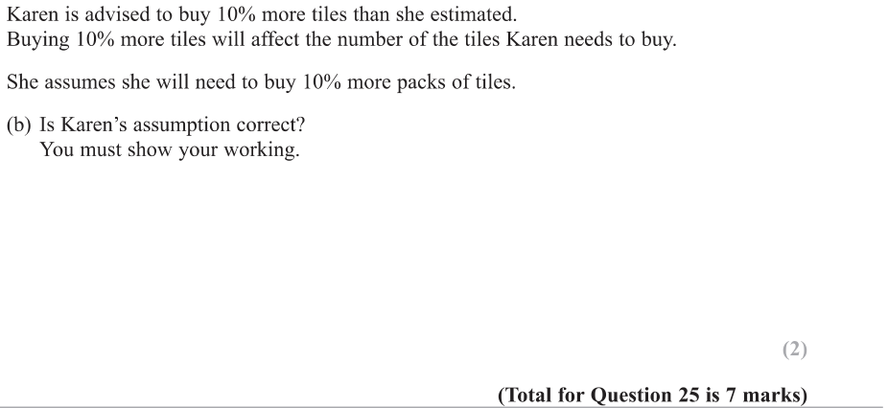

OCR Thursday 07 November 2019- Morning (Non-Calculator) Foundation Tier
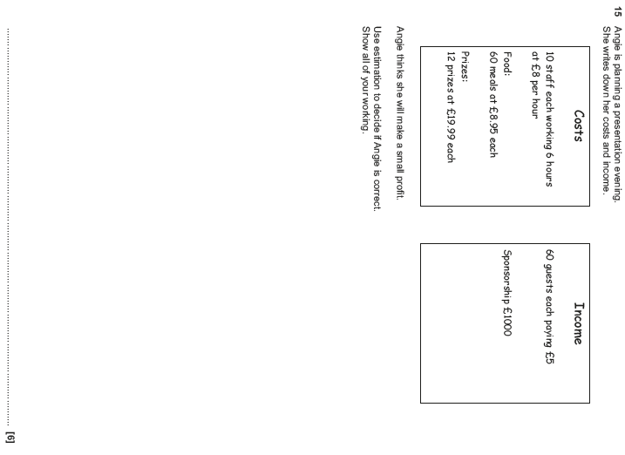

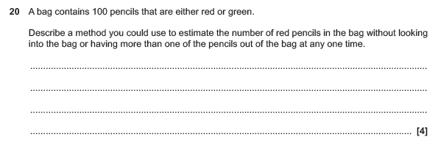

OCR Thursday 6 June 2019 – Morning (Non-Calculator) Foundation Tier
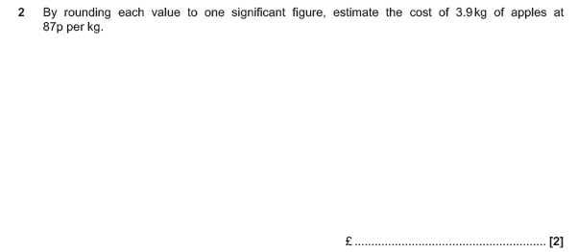

OCR Thursday 8 November 2018 – Morning (Non-Calculator) Foundation Tier

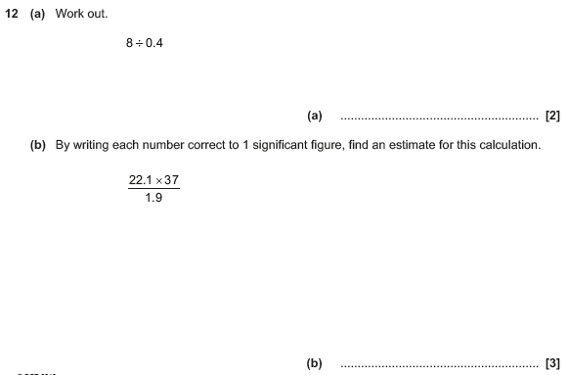

OCR Monday 12 November 2018 – Morning (Calculator) Foundation Tier
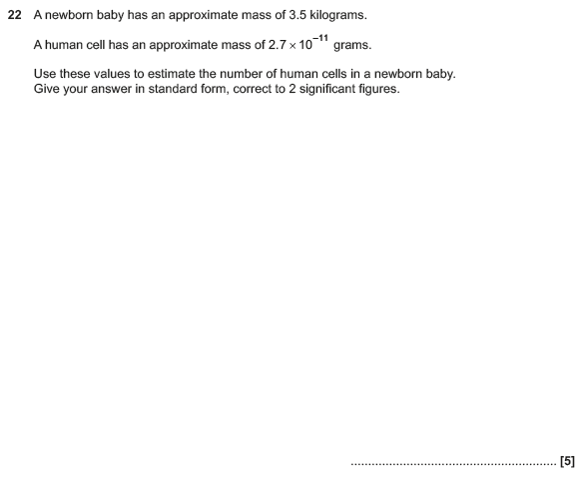

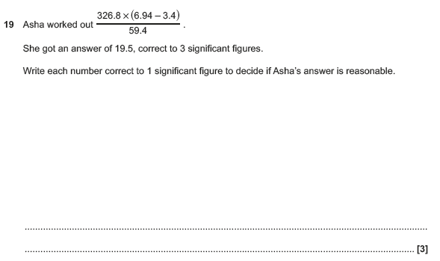
OCR Tuesday 12 June 2018– Morning (Calculator) Foundation Tier

OCR Monday 6 November 2017– Morning (Calculator) Foundation Tier
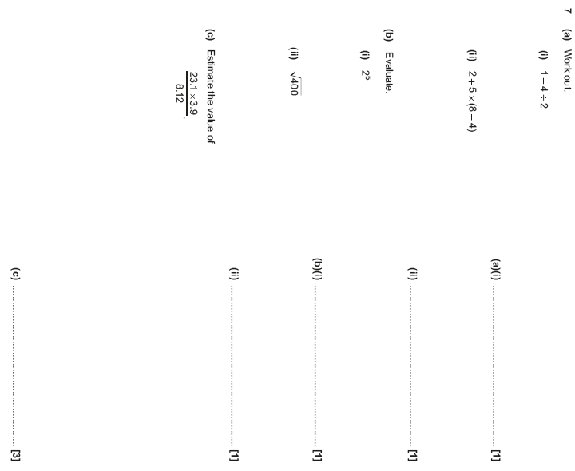

Pearson Edexcel – Sample Papers - Paper 1 (Non-Calculator) Foundation Tier

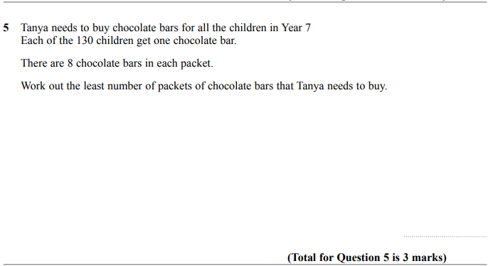

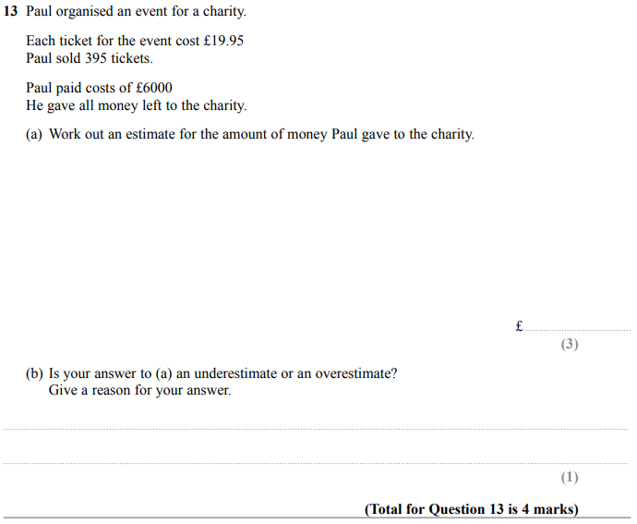

Pearson Edexcel –Sample Papers - Paper 2 (Calculator) Foundation Tier

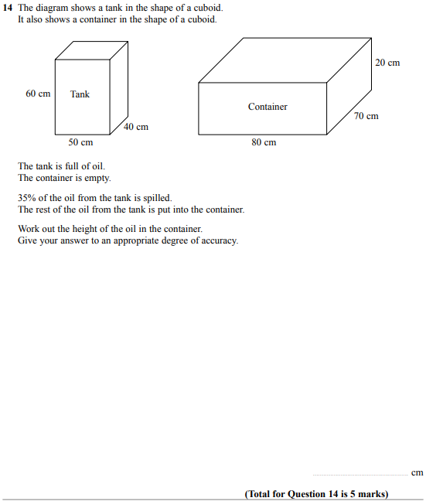

Pearson Edexcel –Sample Papers - Paper 2 (Calculator) Foundation Tier

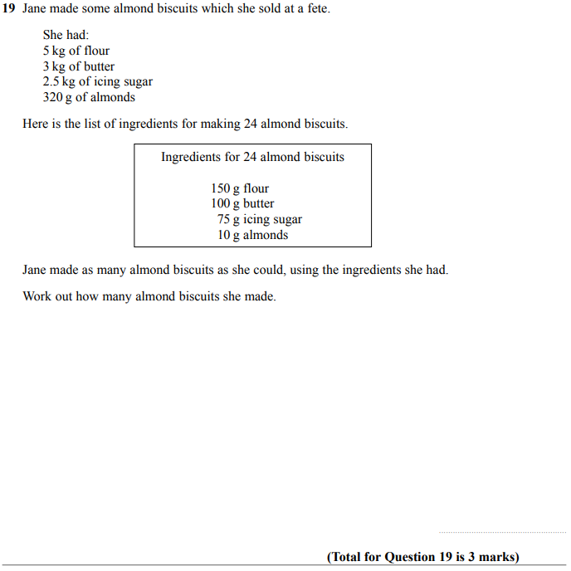

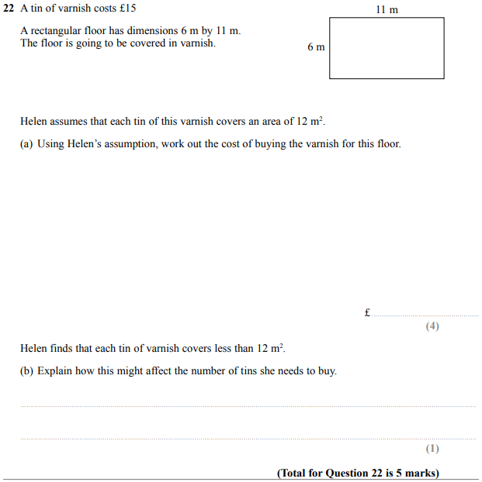

OCR Thursday 8 June 2017 – Morning (Non - Calculator) Foundation Tier

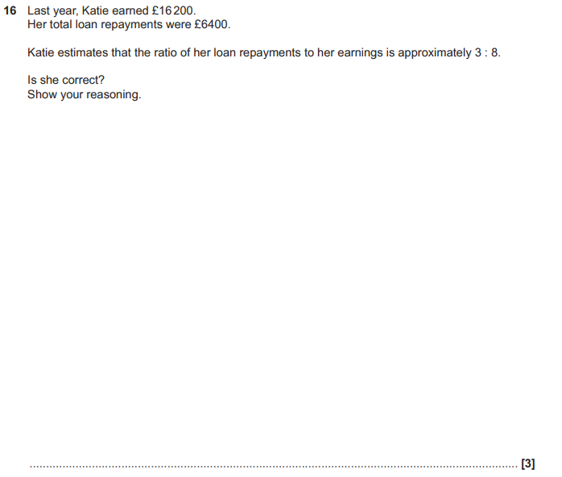

OCR Tuesday 13 June 2017 – Morning (Calculator) Foundation Tier

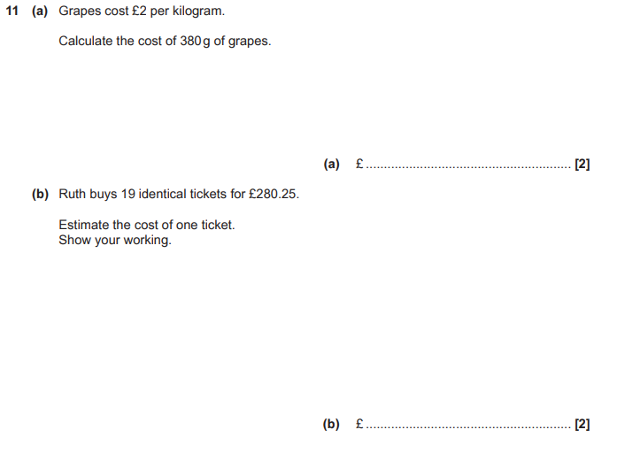

OCR Sample Question Paper 2 – Morning/Afternoon (Non - Calculator) Foundation Tier

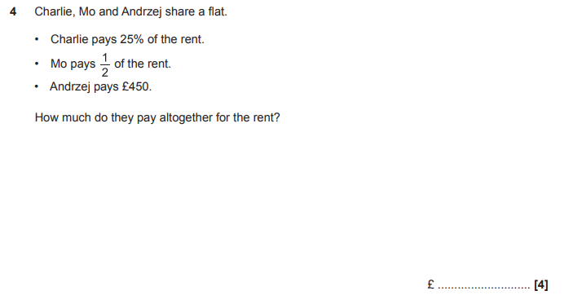

OCR Sample Question Paper 2 – Morning/Afternoon (Non - Calculator) Foundation Tier

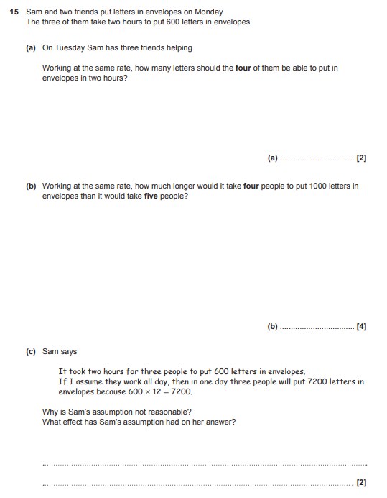

AQA Monday 8 June 2020 – Morning (Calculator) Foundation Tier

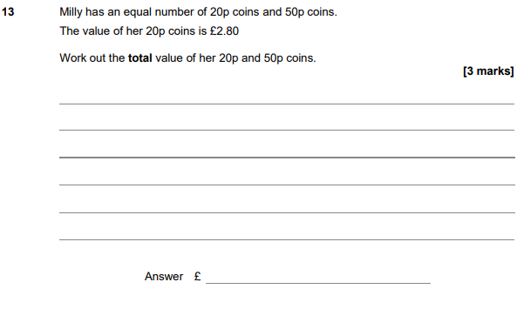

AQA Thursday 6 June 2019 – Morning (Calculator) Foundation Tier

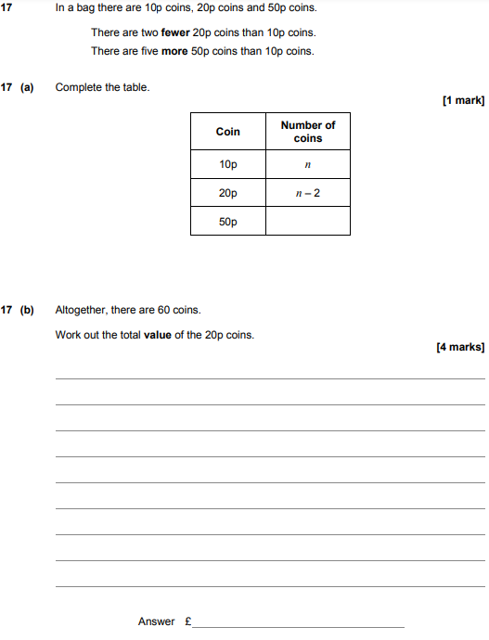

AQA Thursday 8 November 2018 – Morning (Calculator) Foundation Tier

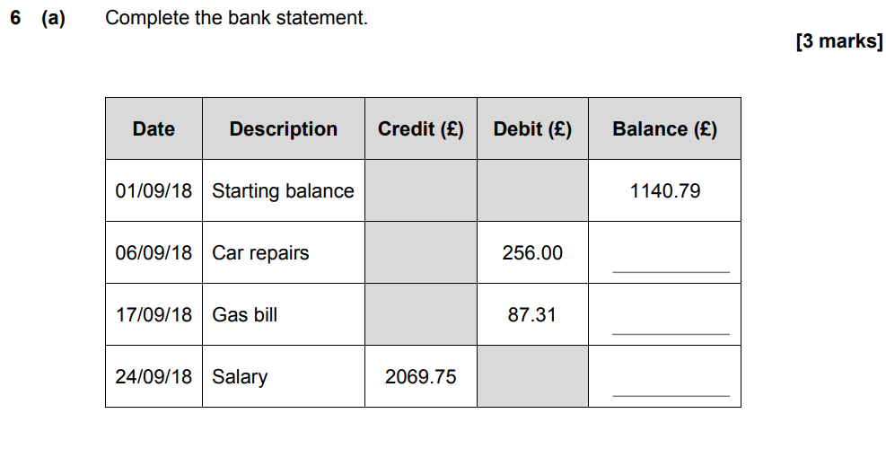
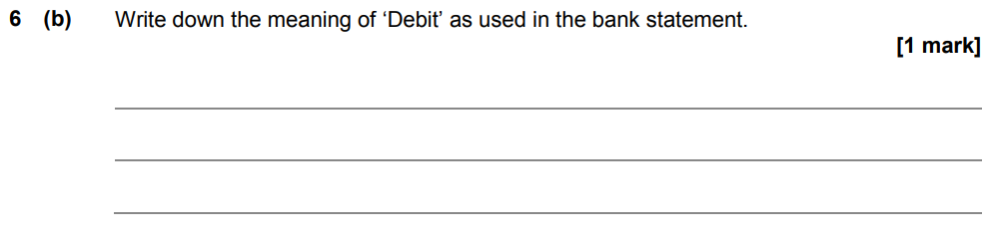

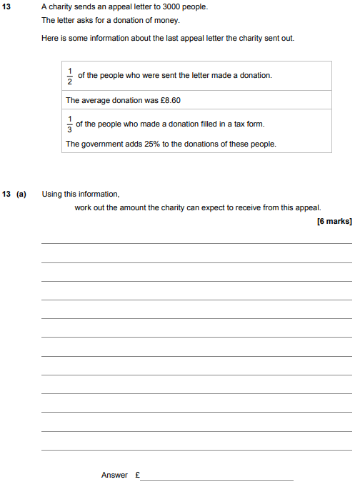
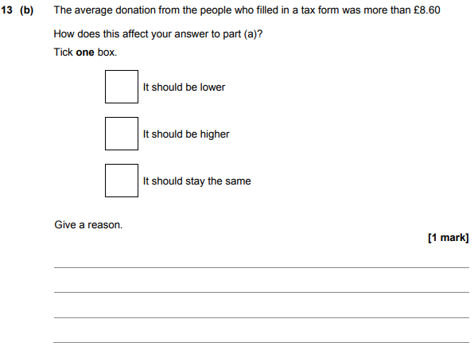

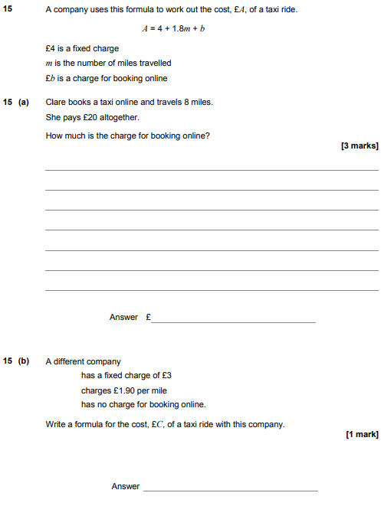

AQA Monday 12 November 2018 – Morning (Calculator) Foundation Tier

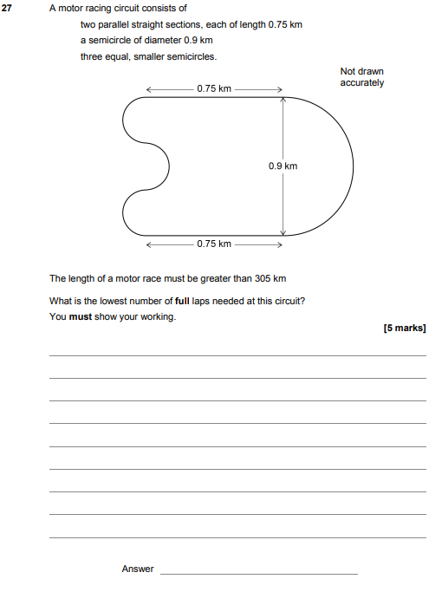

AQA Thursday 7 June 2018 – Morning (Calculator) Foundation Tier

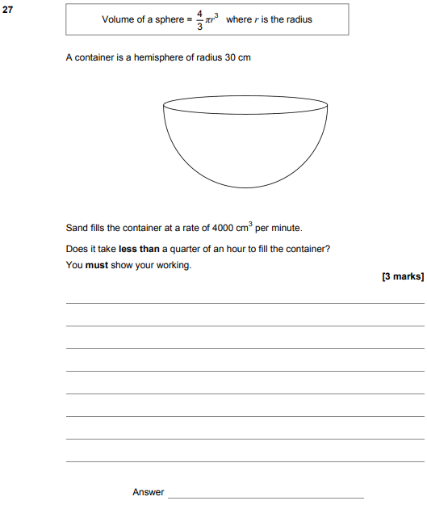

AQA Tuesday 12 June 2018 – Morning (Calculator) Foundation Tier

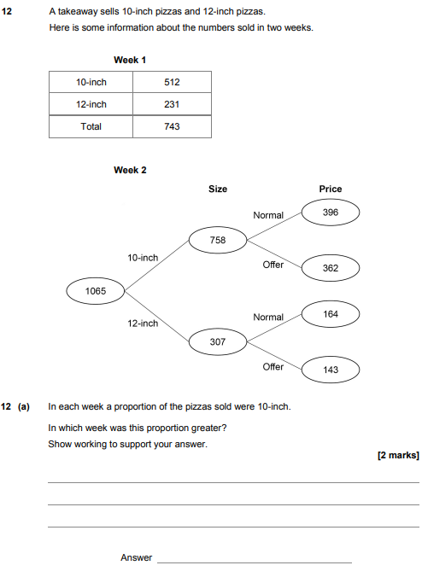

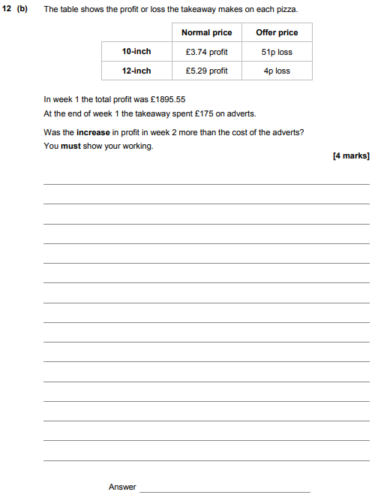

AQA Wednesday 8 November 2017 – Morning (Calculator) Foundation Tier

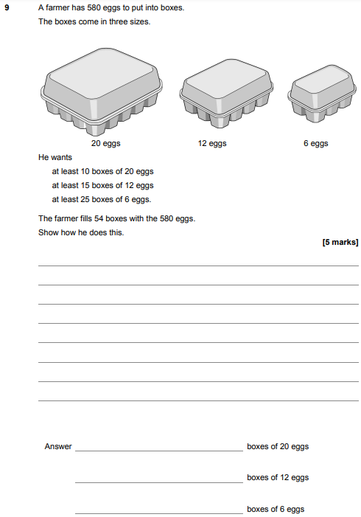

AQA Thursday 25 May 2017– Morning (Non-Calculator) Foundation Tier

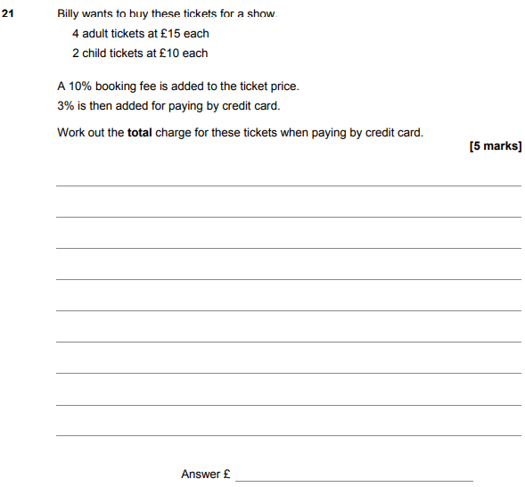

AQA Thursday 8 June 2017– Morning (Calculator) Foundation Tier

